AUTHORIZATION AGREEMENT FOR DIRECT DEPOSIT
I

Name : PurnaDivya Thuraga
Address : 17300 NW 68th Ave, APT 117, Hialeah -33015, Florida
Phone : 786-635-8889
S. S. No. : 674-69-9689
Date of Birth : 27-Aug-1987
Name of Bank : Bank of America
Bank Address : 8001 Villa Park Drive
Henrico, VA 23228

Bank Transit/ABA No. :011000138

Your Bank Account No. :004669689363

Type of Account :  CHECKING

I authorize the ADP to make deposits to my account as indicated.
I also authorize any necessary debit entries or adjustments for entries made in error to my account.

Signature 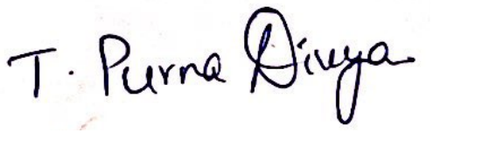 Date ___07/11/2022__________

ATTACH A BLANK COPY OF YOUR PRINTED CHECK

